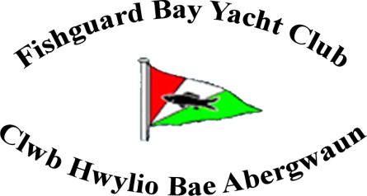
www.fbyc.org.uk

AGM 2015
COMMODORE’S REPORT

It gives me great pleasure to report on the Club activities during 2015.
- Membership.
The Club has accepted 21 new members this year. The total adult membership is 167 comprising of 46 couples, 60 singles and 15 life members. Additionally we have 32 cadets. The total Club membership is therefore 199.
2.On the water.
a] Sailing.
Sailing Committee – Andrew Clark [Sailing Captain], Trevor Morris, Jeff Turner [Cruiser representative], Gail Strawbridge, Mathew Pritchard, Brian Murphy and Jill Chilton.
The sailing section continues to attract full capacity membership with the maximum of 30 juniors enrolled this season. Our location and facilities also continues to attract interest with the Club hosting the Open Winter RYA Training Regional Course in February and the Welsh Optimist Squad Training in March.
In addition to the racing activities described below our sailors participate in learning and practice sessions on a weekly basis. The “intermediate” sessions are managed by Mathew Pritchard and Trevor Morris, and the “advanced” sessions by Jeff Turner, Andrew Clark and Brian Murphy with Gail Strawbridge providing the management support.
i] RYA OnBoard John Merricks Sailing Trust Award – the Club were delighted to learn that Amelia Grant Jones was successful in her application for this prestigious sailing award, and selected to receive an Optimist dinghy as her prize. The selection panel received a large number of high quality applications from throughout the UK, which made selecting the final 14 winners extremely difficult. Amelia retains exclusive ownership of the dinghy for two years [with free insurance] and then the dinghy reverts to FBYC ownership thereafter. She has made good use of her prize during the season by competing and attaining excellent results in a number of regatta’s, as shown below. Well done Amelia!

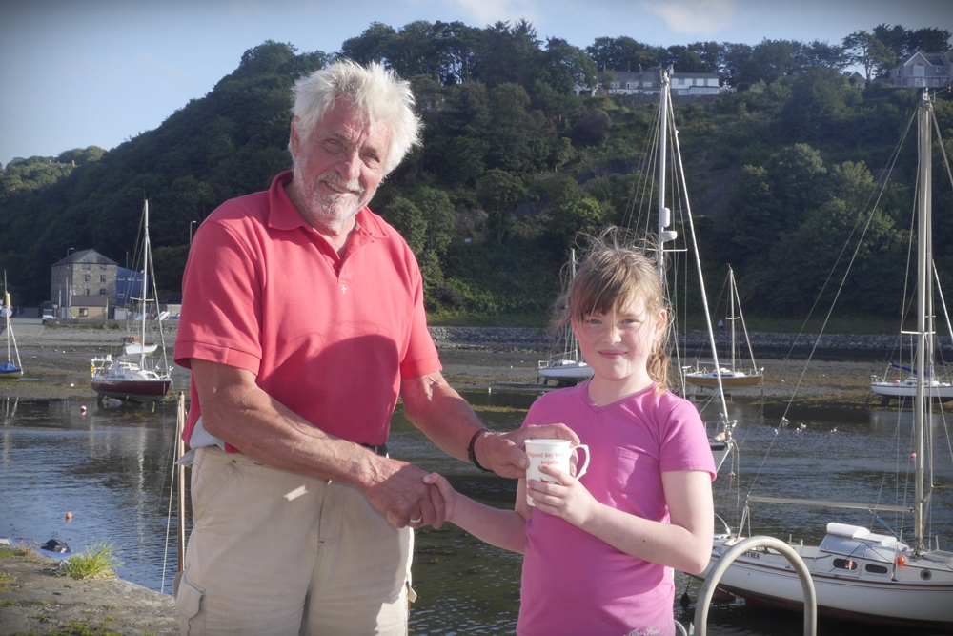
Club Vice Commodore Trevor Morris presents Amelia
with a Club Regatta prize.

ii] Club Dinghy Regatta.
Three separate races took place on a sunny 8th August with a force 4 off-shore wind which tested the competitors’ abilities. Eighteen dinghies competed with Amelia, Bethan Owens and Iolo Davies the youngest sailors competing in their Optimist dinghies, and each successfully completed every race.
Results: Seniors – 1st Christian Smart, 2nd Dan & Ruby Jackson, 3rd Mike Corney. Toppers – 1st Finn Robarts, 2nd Lou Bowman, 3rd Evie Jones. Optimists - 1st Amelia, 2nd Bethan, 3rd Iolo.
iii] Club Cruiser Regatta.
Three cruisers raced on a wet and windless 22nd August but valiantly completed the course within the prescribed time.
Results: 1st Jeff Turner in Dawn [solo], 2nd Chris Reynolds in Tonkawa [with daughter Lucia], 3rd Peter Kedward in Suanthea [with Rick Mabey and Trevor Morris].
iv] FBYC participation at other events.
As in previous years our young sailors have been busy competing around the UK at various regattas. Of special note is the performance of Tom Renny in his second year in the Welsh National Topper and GBR squads. His busy schedule for this season includes:
National Series 1 at Rutland SC 3rd /127
National Series 2 at WPNSA, Weymouth 12th/140
National Series 3 at Queen Mary SC, West London 9th/144
National Series 5 at Lowestoft YC 8th/134
National Series at Carsington SC, Derbyshire 4th/146
Welsh Zone at Pembs YC 1st
Welsh Youths at Pwllheli YC 2nd overall, 1st Welsh sailor
Welsh Championships at Llandegfedd SC 1st
World Championships at Riva del Garda, North Italy 12th
National UK Championships at WPNSA 4th
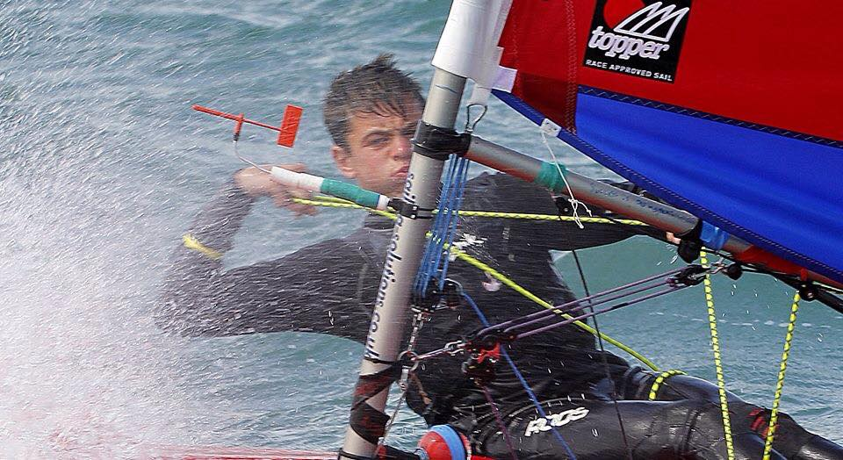
Tom Renny in action.

Other regattas attended by our sailor include:
Welsh Youth and Junior Championships at Pwllheli
Topper, Tom Renny 2nd/31
Finn Robarts 14th
Evie Jones 29th
Regatta Fleet, Amelia Grant Jones 9th
Welsh Topper Championship at Llandegfedd
Tom Renny 1st
Finn Robarts 12th
Llangorse OnBoard Regatta
Toppers – Gold Fleet – Joshua Price 4th
Silver Fleet – Dan Cleary 3rd
Freya Terry 5th
Training Fleet – Daisy Terry 5th
Optimist Silver – Amelia Grant Jones
RYA Zone Championship, at Bala
Toppers – Finn Robarts 7th/23
Josh Price 10th
Evie Jones 14th
Freya Terry 21st
4.2 – Daniel Cleary 7th/12
Optimists – Amelia Grant Jones 30th/40
Club Youth Racing Circuit [CYRC].
The Club hosted the final meeting of the Pembrokeshire “circuit” in September which attracted a record number of entries. During this event our sailors achieved the following results:
Topper Gold Fleet – Finn Robarts 2nd
Silver Fleet – Freya Terry 1st
Topper 4.2 - Daniel Cleary 1st
Daisy Terry 3rd
Optimist Sliver – Amelia Grant Jones 5th
The overall CYRC 2015 season results were:
Topper Gold Fleet – Finn Robarts 2nd
Joshua Price 6th
Silver Fleet – Freya Terry 1st
Topper 4.2 – Daniel Cleary 1st
Daisy Terry 3rd
Optimist Silver – Amelia Grant Jones 5th.
v] RYA Training Centre. 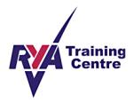
Sub-Committee: Trevor Morris [Principal], Mathew Pritchard [Senior Instructor/Examiner], Jo Hewitt [Child Protection Officer], Gail Strawbridge [Administrator].
During the second operational year the Centre has successfully trained and examined 9 Dinghy Level 1, 2 Powerboat Level 2, 5 Powerboat Safety and 6 First Aid. The two latter qualifications gained by Club members have been particularly useful, as this has extended the number of rescue boat personnel available for supervision of dinghy sailing sessions and regattas.
vi] Sponsorship.
The Club is very grateful to Stena Line and Conygar Investment Ltd whose generous donations allowed the Club to obtain a new cylinder marker buoy, and a donation towards a replacement engine for the safety boat. 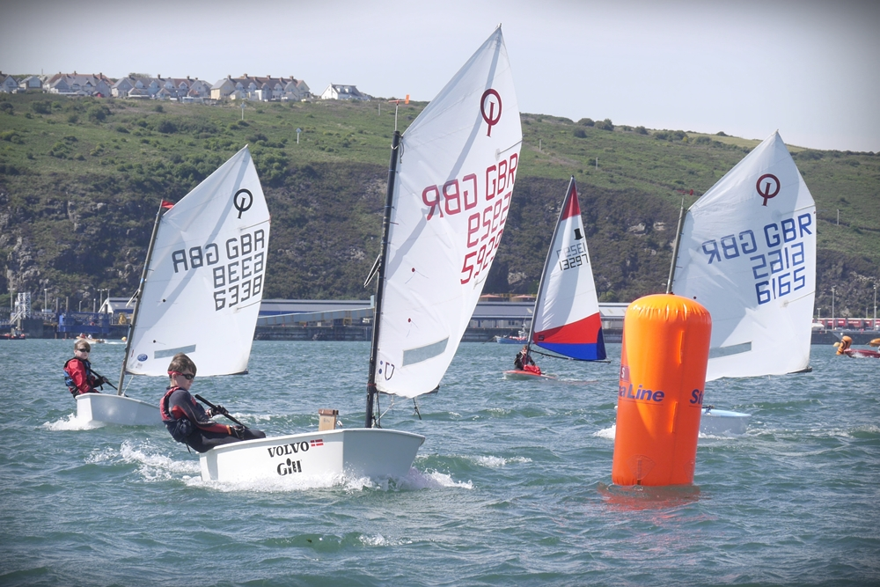
The Optimists round the new Stena Line buoy during the Dinghy Regatta.

b] Rowing.
Rowing Committee: Candy Tanseet [Chair], Emma Phillips [Secretary], Rick Mabey [Membership Secretary], Rachel Davies [Treasurer].
i] Events
The 8 mile Dinas Head Challenge from Goodwick beach to Newport beach took place in June. ‘Moby Dick’, crewed by the Mixed Babes finished 4th in their category; ‘Awel Las’, crewed by Thorsome finished 5th and ‘Margaret’, crewed by Derek’s Dummies finished 3rd.
In September three of our crews competed in the 21.6 miles Great River Race on the Thames. The men’s over 60s team, sculling the “Margaret”, completed the course in 2 hours 54 minutes in 29th position; the men’s team rowing the “Awel Las” completed in 2 hours 43 minutes and the mixed crew in the “Moby Dick” were 3rd in the Celtic longboats veterans’ category in 2 hours 53 minutes. An excellent effort by the crews, particularly considering the choppy water and strong headwinds they experienced during the full course of the race. Our crews also raised money for two charities, Reverse Retts and Cancer Research UK. Almost £2,000 has been raised so far and further donations can be made to the ‘just giving’ links
https://www.justgiving.com/Jo-Hewitt1/
https://www.justgiving.com/Anwen-Evans7/

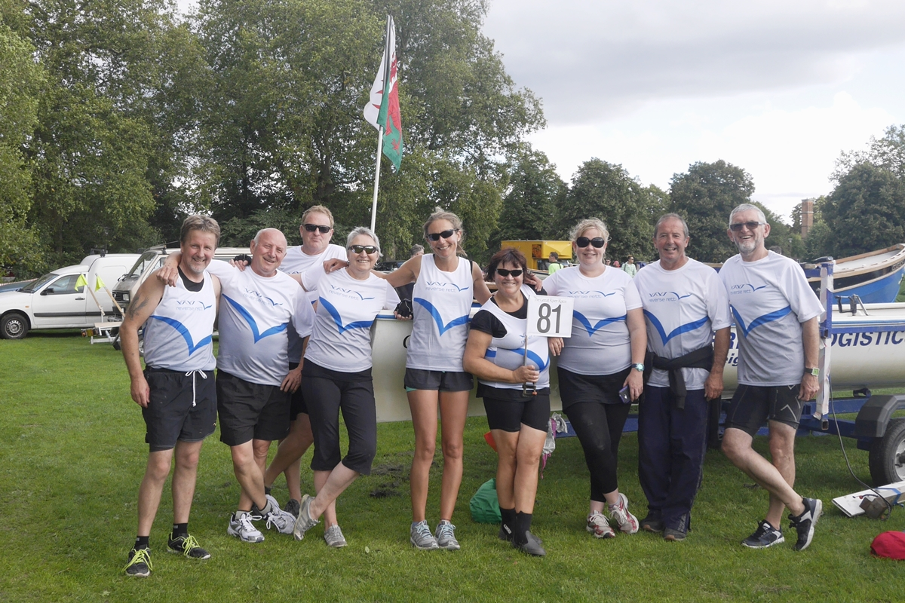
Great River Race FBYC representatives l-r Mike Hughes, Rick Mabey, John Baiden, Amanda Griffiths, Rachel Davies, Candy Tanseet, Jo Hewitt, Derek Miles and Eifion Griffiths.
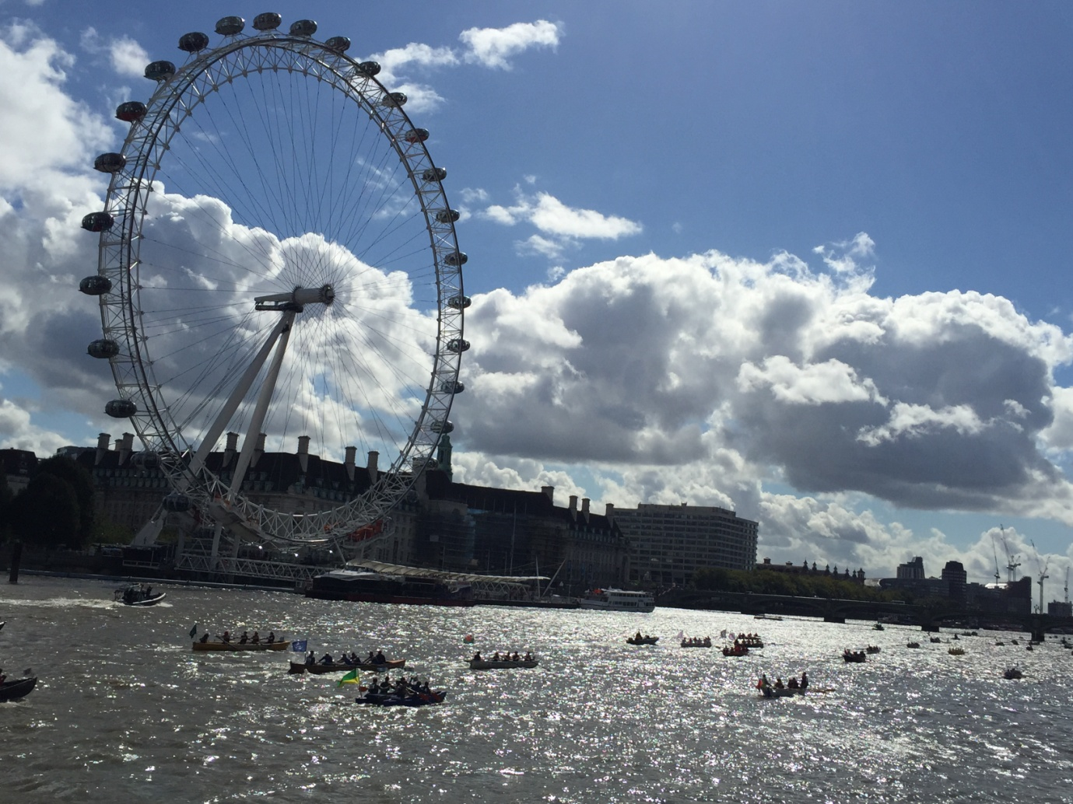
The Great River Race – passing the London Eye.
ii] Welsh Sea Rowing Association League.
The Club hosted the League event on the 11th July with a total of 56 crews competing. The Club was represented by four crews with the Juniors Under 16 finishing 3rd with our novice crew competing in the same race; the Ladies finished 7th; Seniors 2nd and the Mixed Super Vets also 2nd.
In the final South Wales League overall club points our crews achieved a combined position of 11th from a total of 24 clubs. The Men’s Senior crew finished 6/29, the Ladies 26/29, the Mixed Vets 8/12, the Junior [Under 16] 4/7 and our Mixed Super Vets finished CHAMPIONS 1/14.
In the combined classification of North and South Wales our Mixed Super Vets have been crowned CHAMPIONS of WALES! They were the only South Wales crew in this joint League, gaining 61 points overall with second place Porthmadog on 24 points.

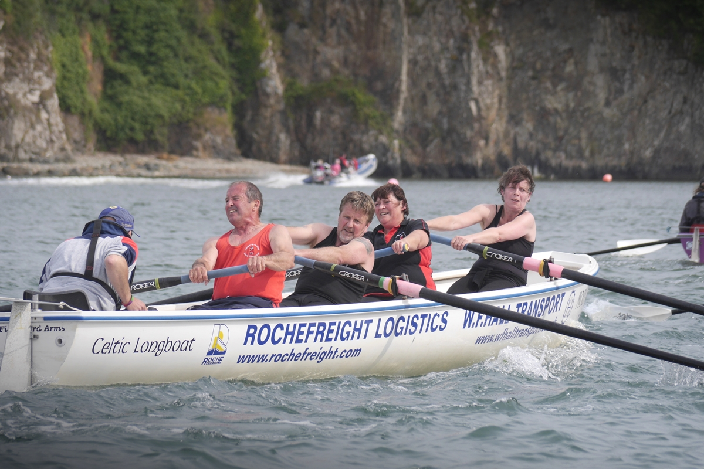
The Welsh Sea Rowing Association Mixed Super Vets Champions l-to-r James Griffiths, Derek Miles, Mike Hughes, Candy Tanseet and Rebecca Williams.

3. Planned improvements to the Club house.
The Club have decided to prioritise the development of the toilets/changing rooms, letters having been distributed to a number of organisations with local affiliations requesting donations. An application to the Lottery Funding will follow.
The existing ramp entrance is no longer fit for purpose as an entrance for the disabled. Permission has been sought from PCC to extend the size of the ramp and permission has been granted. The new ramp will form part of the toilets/changing rooms project.

Tony Davies,
Commodore.
16th October 2015.
Thanks to Rick Mabey for the photographs, and here are a few of Rick himself!
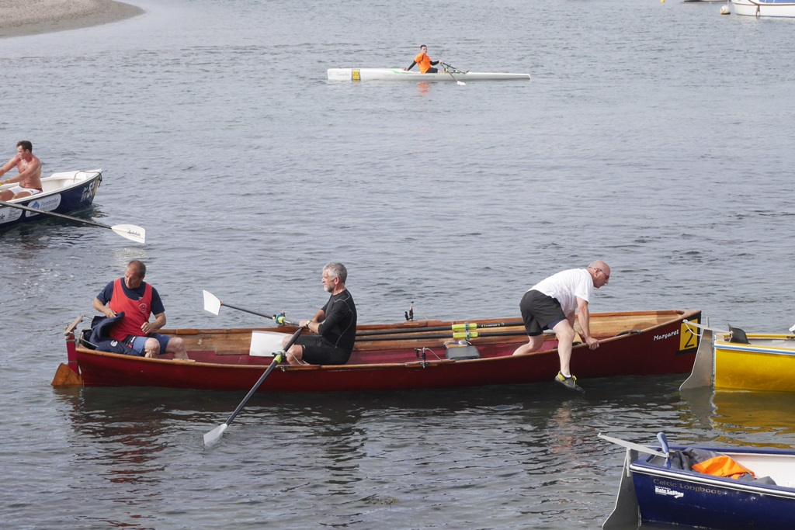
I’m fed up listening to these two – I’m off ashore.
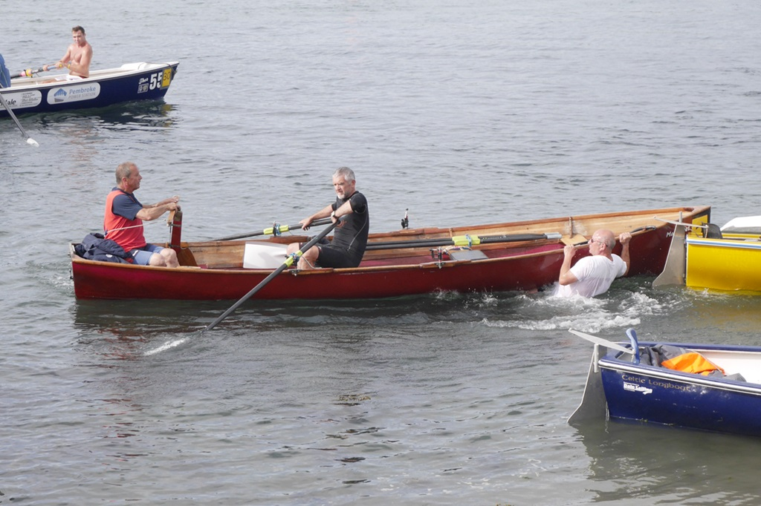
Damn! I hope no one has taken a photo of me.

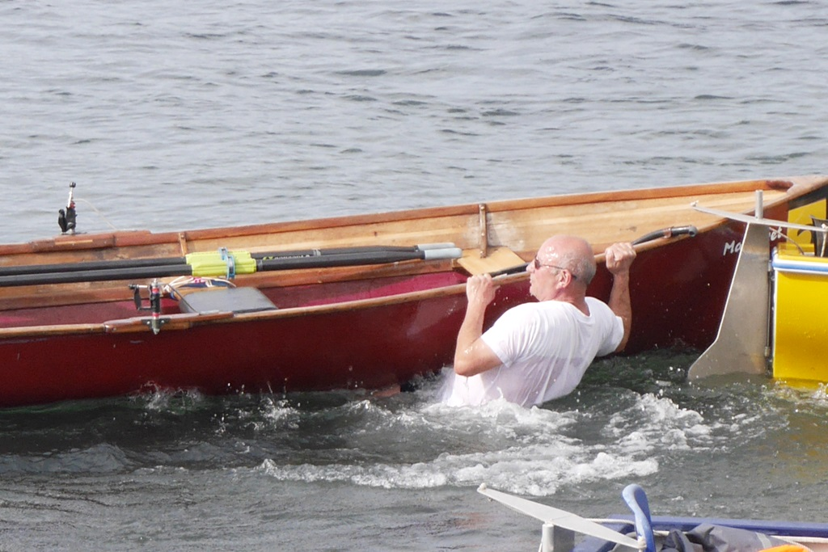
Hey you two – MAN OVERBOARD!

