MINUTES OF THE FISHGUARD BAY YACHT CLUB AGM
HELD AT THE CLUBHOUSE ON 27 OCTOBER 2017

There were 27 members present and apologies were received from 10 members.

The Chair Mandy Griffiths welcomed members to the 70th AGM. She thanked people for attending and for the good turnout of members.
1. The minutes of the 2016 AGM were read. Copies of the Commodore’s Report and the Treasurer’s Report were available and can be accessed on the club website.
Proposed that the minutes be adopted: Peter Cross Seconded Candy Tamsett

2. Matters arising -
None

3. Commodore’s Report – Trevor Morris gave a report on club activities over the previous year and thanked all the volunteers for the time they gave. The full report is attached. It will also be available on the website.
4. Treasurer’s Report – Peter Coggins reported that the accountant has produced the accounts for 2016. His report is attached.

Proposed that the accounts be adopted: Martin Sykes Seconded: Andy Bingham

5. Election of Officers
Trevor Morris is stepping down as Commodore but will remain on the committee.
Martin Sykes will serve as Commodore.
Geoff Turner will serve as Vice Commodore as well as holding the post of Sailing Captain.
Amanda Griffiths will take on the post of Hon. Treasurer.
Gail Strawbridge will continue as Hon. Secretary.
There is no Chair and the duties will be shared amongst the committee members.

6. Election of Committees
Executive Committee
Rick Mabey continues as Membership Secretary.
Mike Hughes and Michael Renny were both elected on to the committee.
Other members will remain: Peter Cross, Peter Kedward, Paul Booth, Lee Robinson.

Sailing Committee
Geoff Turner remains as Sailing Captain and other members remain the same – Trevor Morris, Matthew Pritchard, Brian Murphy, Gail Strawbridge.

Entertainments Committee
No new nominations – the present members will remain
Gaye Oliver, Mandy Griffiths, Paul Booth, Lee Robinson, Martha Owen, Rob Evans, Gail Strawbridge.

Wines Committee – at present there are no members.

7. Moved – to re-elect Messrs Pritchard and Co. as auditors to the Club
Proposed: Peter Coggins Seconded: Trevor Morris

8. No notice of any new motion was received.

9. Any Other Business
The Chair reminded members that fees will rise by a small amount in 2018. This is essential as a way of raising funds toward the much needed refurbishment work. People can also contribute to revenue by supporting any events held in the club.

She thanked everyone who has served on the committee and all those who have supported
and contributed to the club over the past year, making it a warm and welcoming place.
She thanked everyone for attending the AGM this evening.

There being no further business, the meeting closed at 7.35pm.
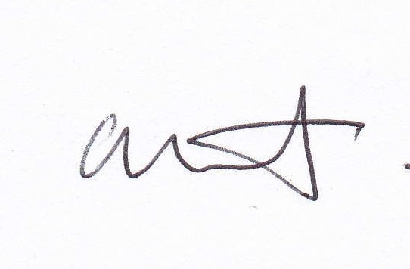

Chair

