MINUTES OF THE FISHGUARD BAY YACHT CLUB AGM
HELD AT THE CLUBHOUSE ON 12 OCTOBER 2018

There were 21 members present and apologies were received from 6 members.

The Chairman Peter Cross welcomed members to the 7^{1st} AGM. He firstly asked for a minute's silence in remembrance of two well respected members who passed away this year, Rita Pritchard and Margaret Morris.
1. The minutes of the 2017 AGM were read. Copies of the minutes and the Commodore’s Report were available and can be accessed on the club website.
Proposed that the minutes be adopted: Peter Cross Seconded A Griffiths
The Chairman added that although no-one had taken up the role of the Chair at the last AGM, he had subsequently been elected to the position by the Executive Committee and he appreciated the confidence they had shown in him by this. He looked forward to an active and prosperous 2019 for the club.

2. Matters arising -
None

3. Commodore’s Report – Martin Sykes gave a report on club activities over the previous year and thanked all the volunteers for the time they gave. The full report is attached and will be available on the website.
4. Treasurer’s Report – Amanda Griffiths reported that the accountant has produced the accounts for 2017. These were distributed.
The overall profit for the year was down – income generally was down and the expenses were increased.
The Accountants expressed concern that we are losing our profit margin on bar prices.
The Cafe contributes to the income.
Subscriptions were up slightly, the Entertainments account was down a little.
The Storage Shed is full with a waiting list.
We received less in donations (the previous year there were donations for the new floor)

Proposed that the accounts be adopted: M Renny Seconded: T Davies

Chairman's comment – the accounts show the difficulty inherent in running a small club in a rural area with an aging population and which has an older committee. We need to think about serving our group of stalwart members and to attract more younger members.

5. Election of Officers
Martin Sykes will continue to serve as Commodore
Gail Strawbridge has resigned from the post of Hon. Secretary but will continue to serve on the committee.
Other Officers remain - Peter Cross Chairman, Geoff Turner Vice Commodore/Sailing Captain, Amanda Griffiths Hon. Treasurer.

6. Election of Committees
Executive Committee
Trevor Morris has resigned.
Other members will remain: Peter Kedward, Paul Booth, Lee Robinson, Mike Hughes and Michael Renny

Sailing Committee
Geoff Turner remains as Sailing Captain and other members remain the same – Nicola Cleary Sailing Principal, Trevor Morris, Matthew Pritchard, Brian Murphy, Gail Strawbridge.

Entertainments Committee
No new nominations – the present members will remain
Gaye Oliver, Amanda Griffiths, Paul Booth, Lee Robinson, Martha Owen, Rob Evans, Gail Strawbridge.

Wines Committee – at present there are no members.

7. Moved – to re-elect Messrs Pritchard and Co. as auditors to the Club
Proposed: Peter Cross Seconded: Amanda Griffiths

8. Geoff Turner presented the rationale for the change in Rule 10. At present, people applying for membership have to be proposed and seconded. We have been applying for grants from the National Lottery Awards for All, and their conditions say that there should be no barriers to membership such as the need for someone to be recommended by a current member. It is intended that new members will complete an application which will be considered at committee meeting.
Proposed to adopt the change – Geoff Turner Seconded Trevor Morris
It was carried unanimously.

9. Any Other Business
Nothing raised.

There being no further business, the meeting closed at 7.50pm.
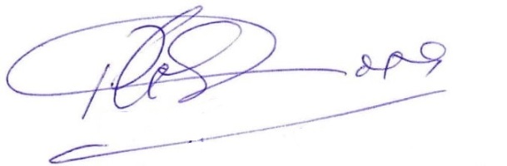

Chairman

